Lesson Plan | 4ESO | Teacher Candidate(s): | Grade: A | Equipment  mat, bench
 |  | 1. Drandel Averion Sahagun
 |  | 2. Ahmed Hassan
 |  | Name Activity: Cardio and Dips
 |  |  | Students:  T  S S S S S S  S S S S S  S S S S S S  s s s s s | References:  https://www.youtube.com/watch?v=YQQfhILVR7c (Stretches)

Start
Name | Duration | Explanation
Jumping jacks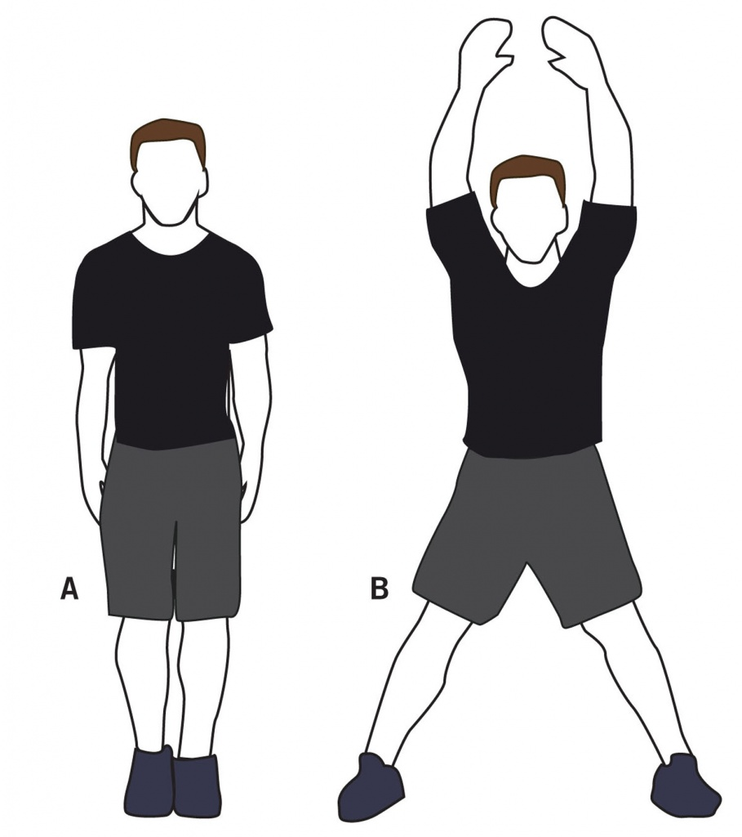 | 25s - 10s  4 times  (2,20 min) | Jump while raising arms and separating legs to sides. Land on forefoot with legs apart and arms overhead. Land on forefoot with arms and legs in original position and repeat.
Step-up onto chair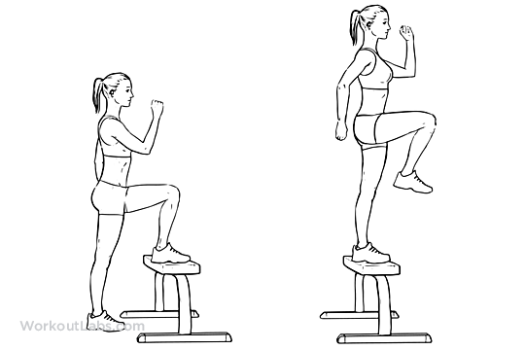 | 20s - 10s  4 times  (2 min) | Place your to the starting position by stepping down with the right foot, then the left to both feet are on the floor.  Complete 10-15 steps leading to the left foot, then repeat another 10-15 steps leading to your left foot.
Squat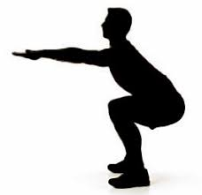 | 15s - 10s  4 times  (1,40 min) | Stand with your head facing forward and your chest held up and out.  Place your feet shoulder-width apart or slightly wider. Extend your hands straight out in front of you to help keep your balance.  Lower down so your thighs are as parallel to the floor as possible, with your knees over your ankles. Press your weight back into your heels.  Keep your body tight, and push through your heels to bring yourself back to the starting position.
Triceps dip on chair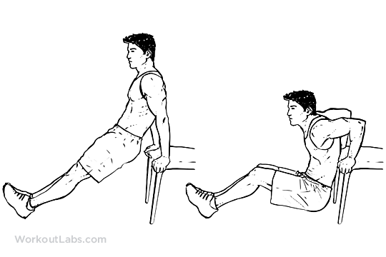 | 25s - 10s  4 times (2,20 min) | The hands should be at a distance from the shoulders on the surface from which you are submerging, with your arms straight. From there, lower until your arms are at a 90 degree angle, then straighten them again, lifting your body.
Plank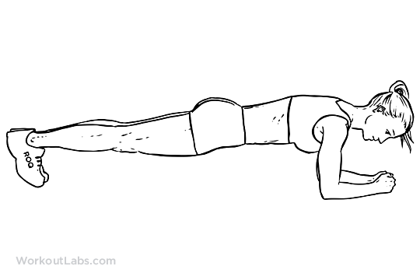 | 20s - 10s  4 times  (2 min) | Lie on your both arms and keep your body straight.
 |  | Repeat all exercises
Stretching | 5 min | Stretching exercises for the foot, ankle, lower leg, thigh, hip, groin, shoulder, neck, upper arm and elbow.

Total Time: 25min 40s

Lesson Plan Instructions
Section 1: Contextual Information

Lesson Plan Component | Directions
Teacher Candidate/s | Ahmed Hassan i Drandel Averion
Grade | A
Name Activity | Cardio
Equipment | Mat, bench
References | -

Section 2: Lesson Activities

Lesson Plan Component | Directions
Column: time | Total time: 25 min
Column: organization | T T  S S S S S S  S S S S S  S S S S S S  s s s s s
Transition | Follow my teammate when I say “go”. When I whistle, stop and rest for few seconds.
Introduction | Transcribe an introduction to the day’s lesson.
Fitness Activity | Explain the fitness activity here and be sure it is aligned to your fitness objective.
Body of Lesson
- Tasks | Describe the task with enough detail so someone else could teach it.  In the first row of the task (a), explain how you will get the students engaged in the activity  In the second row (b) you will describe the task in detail.
- Cues | List cues used for the task.
- Variations | Add modifications to make the tasks easier and harder according to the skill level of the students (examples: change the time, distance, challenges, 3 of people, etc.).
Lesson closure | How you end the lesson
Evaluation of lesson
- Post-planning | Analysis of student performance. What did the students learn in this lesson?
- Teacher reflection | Teacher reflection includes what worked, what didn’t, why, and what to change.

